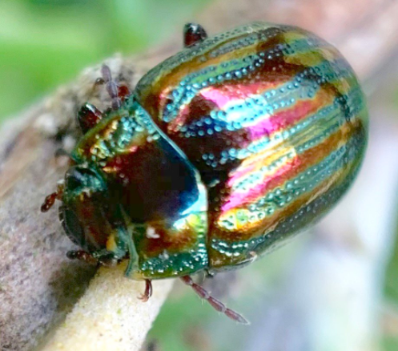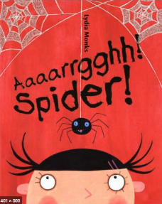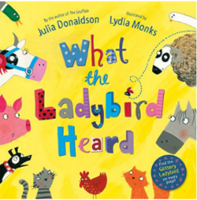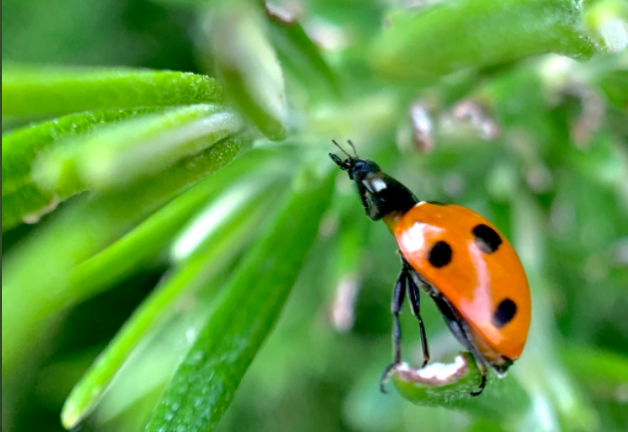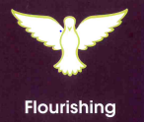01 0020sdew”

**How do minibeasts help us?**

**Our favourite five!**

**Seek a purpose for life; take responsibility for my own well-being and support others with theirs.**

* **How do I know what is good for me?**
* **How do I know when I am upset?**
* **How do I know what to look for in a good friend?**

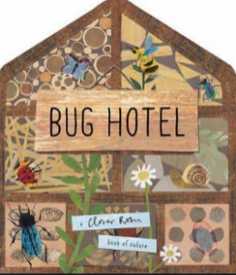

**Outcome**

**Children to design and create a bee hotel.**

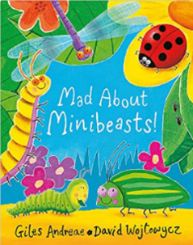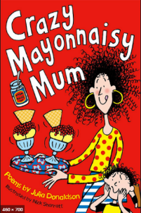

**Metacognition**

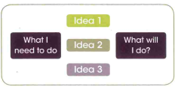

To use pictorial ideas to help the children reflect on the best ideas.

**Knowledge and Skills**

We will know what a habitat is and be able to classify some minibeasts.

I know that some things in the world are manmade and some things are natural.

We will be able to use tools safely.

**Character**

We will be thinking about how nature and outdoor learning is good for our well-being. We will also be building on our work on teamwork and how we can support each other.