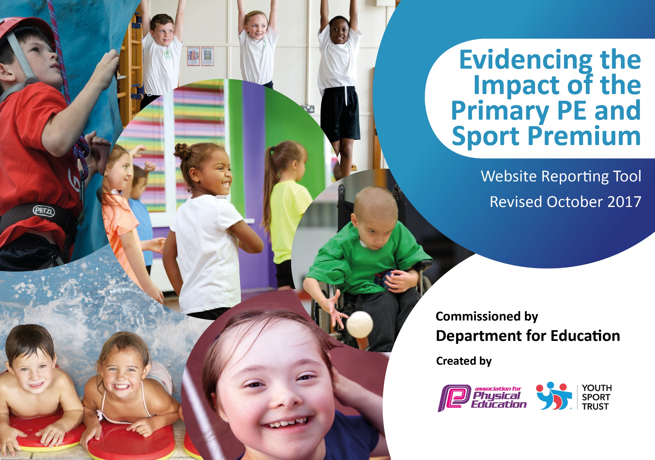

Schools must use the funding to make additional and sustainable improvements to the quality of PE and sport they offer. This means that you should use the Primary PE and Sport Premium to:

- develop or add to the PE and sport activities that your school already offers
- build capacity and capability within the school to ensure that improvements made now will benefit pupils joining the school in future years

Please visit gov.uk for the revised DfE guidance including the 5 key indicators across which schools should demonstrate an improvement. This document will help you to review your provision and to report your spend. DfE encourages schools to use this template as an effective way of meeting the reporting requirements of the Primary PE and Sport Premium.

We recommend you start by reflecting on the impact of current provision and reviewing the previous spend.
Under the Ofsted Schools Inspection Framework, inspectors will assess how effectively leaders use
the Primary PE and Sport Premium and measure its impact on outcomes for pupils, and how effectively governors hold them to account
for this.

Schools are required to publish details of how they spend this funding as well as on the impact it has on pupils’ PE
and sport participation and attainment.
We recommend regularly updating the table and
publishing it on your website as evidence
of your ongoing review into how you are using the money
to secure maximum, sustainable impact. To see an example of how to complete the table please click HERE.

Support for review and reflection - considering the 5 key indicators from DfE, what development needs are a priority for your setting and your students now and why? Use the space below to reflect on previous spend, identify current need and priorities for the future.

Key achievements to date: 2017- 2018 | Areas for further improvement and baseline evidence of need:
- Awarded Gold School Games Mark  - Increased participation in competitive sport by targeting and supporting children to join teams and take part in competitive events where they represent the school.  - Increasing activity levels of children not accessing sport outside of school through targeted use of free after-school clubs  - Using specialist provision and events to enable children with SEN to access a wider range of sporting activities  - Widened the range of sports available to the children through PE and after school clubs.  - Maintained a high profile for sport and active lifestyles for children in school through, for example, visits/training sessions run by high level sportspeople. | - Increasing resilience of PE provision in school by updating knowledge and skills of teaching staff not currently engaged in teaching physical education on a regular basis.  - To strengthen provision for structured active play for upper KS2 at break and lunchtimes  - To support ‘hard to reach’ children to increase activity rates  - To raise awareness amongst KS1 children of the importance of sport and physical activity within the broader context of understanding how they can support their own wellbeing (physical, social, emotional)

Meeting national curriculum requirements for swimming and water safety | Please complete all of the below:
What percentage of your Year 6 pupils could swim competently, confidently and proficiently over a distance of at least 25 metres when they left your primary school at the end of last academic year? | 2016/2017 | 2017/2018
 | 87% | 93%
What percentage of your Year 6 pupils could use a range of strokes effectively [for example, front crawl, backstroke and breaststroke] when they left your primary school at the end of last academic year? | 82% | 83%
What percentage of your Year 6 pupils could perform safe self-rescue in different water-based situations when they left your primary school at the end of last academic year? | 50% | 33%
Schools can choose to use the Primary PE and Sport Premium to provide additional provision for swimming but this must be for activity over and above the national curriculum requirements. Have you used it in this way? | No | No

Action Plan and Budget Tracking
Capture your intended annual spend against the 5 key indicators. Clarify the success criteria and evidence of impact that you intend to measure to evaluate for students today and for the future.

Academic Year: 2017/18 | Total fund allocated: £ 17,800 | Date Updated: 3.7.18
Key indicator 1: The engagement of all pupils in regular physical activity – Chief Medical Officer guidelines recommend that primary school children undertake at least 30 minutes of physical activity a day in school |  |  |  | Percentage of total allocation:
 |  |  |  | 61%
School focus with clarity on intended impact on pupils: | Actions to achieve: | Funding allocated: | Evidence and impact: | Sustainability and suggested next steps:
All children in years 1-6 having 3X40 minute high quality PE teaching each week to improve and sustain fitness levels  All EYFS children having 30 minutes structured physical activity each day  Resources to support active playtimes and lunchtimes.  Play leaders to support structured play at lunchtimes. | - Provision of specialist PE Teacher (not covering PPA)  - Provision of teaching assistant capacity and play resources to enable small groups to be taken out for physical activity each morning  - Purchase range of new play equipment (balance bikes, additional goal posts, balance rockers, skipping ropes etc.) to encourage active play)  - Skipping workshop for all classes  - PE teacher to train pupils and lead activities. | £10,900 | Quality of provision; Very low % of overweight children in school  Quality of provision; Very low % of overweight children in school  Children able to access wider range of play equipment to support active break and lunchtimes  Children actively involved at break and lunchtimes in the structured activities that are available. Children are participating and being encouraged to engage in different sports informally. | Build in resilience by ensuring other teachers’ baseline PE knowledge and skills is up to date.  Develop TAs skills to offer wider range of activities  Consider introduction of ‘Daily Mile’ or similar to complement formal PE provision.  Budget for annual replacement on % of equipment to allow for breakages. Increase resources for upper KS2.  Play leaders to be identified and trained at the end of the previous academic year to ensure
Key indicator 2: The profile of PE and sport being raised across the school as a tool for whole school improvement |  |  |  | Percentage of total allocation:
 |  |  |  | 5%
School focus with clarity on intended impact on pupils: | Actions to achieve: | Funding allocated: | Evidence and impact: | Sustainability and suggested next steps:
Use of PE/Sport/outdoor learning to support the school’s wider objectives for developing character:  - promoting self-confidence and team work skills  - developing resilience and determination  PE incorporated as a core component within a wider programme focused on healthy lifestyle and wellbeing | - PE provision to incorporate school’s values and metacognition focus as means of reinforcing development of character.  - Progressive programme of outdoor education throughout the school.  - Sports Ambassadors – Leadership training for Year 5’s to support KS1 playtimes  - Introduction of Healthy Lifestyles week  - Incorporation of physical activities within breakfast and afterschool club. | £840 | - Children open to new challenges; display more self-confidence across all aspects of school life.  - Children’s have good knowledge about different components of a healthy lifestyle, and how to put these into practice. | Incorporation of PE specific statements in metacognition progression plans.  Review impact of pilot Year 3 residential this year to inform decision on whether to incorporate as ‘permanent’ part of outdoor ed programme.  Strengthen awareness amongst KS1 children of the importance of sport and physical activity as part of wellbeing through more targeted approach in next healthy living week.

Key indicator 3: Increased confidence, knowledge and skills of all staff in teaching PE and sport |  |  |  | Percentage of total allocation:
 |  |  |  | 8%
School focus with clarity on intended  impact on pupils: | Actions to achieve: | Funding  allocated: | Evidence and impact: | Sustainability and suggested  next steps:
Ensure PE teacher has access to latest research and training resources  To train TAs on targeted physical exercise apparatus to enable them to support children | - Membership of School Sports Partnership  - Specific ad hoc training, to ensure safe delivery of EYFS and year 1 active learning.  - Training on how to support SEND and children with additional needs to access PE and sports. | £1410 | Introduction of new approaches and sports to enhance PE ‘offer’  TA using the support given to deliver their own sessions with children. | Increasing resilience of PE provision in school by updating knowledge and skills of teaching staff not currently engaged in teaching physical education on a regular basis.
Key indicator 4: Broader experience of a range of sports and activities offered to all pupils |  |  |  | Percentage of total allocation:
 |  |  |  | 14%
School focus with clarity on intended  impact on pupils: | Actions to achieve: | Funding  allocated: | Evidence and impact: | Sustainability and suggested  next steps:
To continue to offer all pupils access to a range of different sports and activities during the course of the year, including gymnastics, dance, striking and fielding, athletics, cross country, tennis and invasion games.  To provide opportunities for less active children to access new sports and active play in a safe environment  To support all children to be able to ride a bike safely | - Membership of School Sports Partnership gives access to range of specialist sports tuition and events.  - Sports premium to support new after school club targeted at children who need additional support to increase activity levels and physical skills.  - Training on balance bikes for all EYFS/ YR1 children  - Year 5/6 Bikeability Training | £2480 | Children’s participation in wide range of sports.  Very low % of overweight children in school;  Increased take up of after school sports clubs.  Improved activity rate of children targeted for additional support.
Key indicator 5: Increased participation in competitive sport |  |  |  | Percentage of total allocation:
 |  |  |  | 12%
School focus with clarity on intended  impact on pupils: | Actions to achieve: | Funding  allocated: | Evidence and impact: | Sustainability and suggested  next steps:
Increase range of competitive sports included within the PE curriculum at school (e.g. introduction of Handball; Dartmoor 5 ball as full schemes of PE planning.)  All children to be given the opportunity to represent Shaldon in competitive sport whilst at the school. during their time at Shaldon.[/ As well as raising profile of sport, this supports the school’s wider school improvement work on character education. | - Buy/ renew necessary equipment to expand range of for competitive sports  - PE teacher to deliver as part of new sports curriculum  - Membership of local school sports partnership to enable access to competitive events.  • PE Coordinator targeting children to represent the school  • Entering wider range of sports competitions (e.g. golf and mini tennis) to offer wider range of Links with local sports clubs to inspire the children to achieve | £2140 | Through curriculum; Children Acquiring skills in new sports; Success at competitive events.  100% of year 6 children given opportunity to represent the school in at least one competitive sporting event.  Events for new sports – such as competitive cycling and golf – have encouraged children who had not represented the school previously to access events.

